Test 1(test1 and test2)
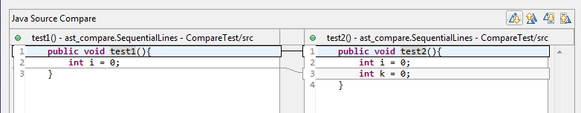
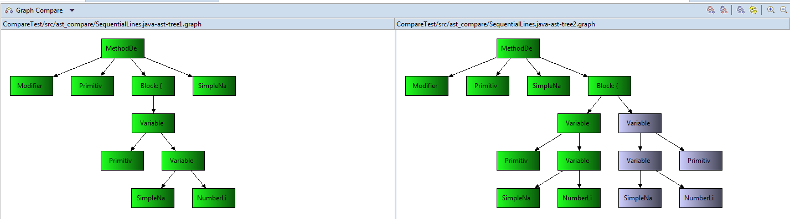
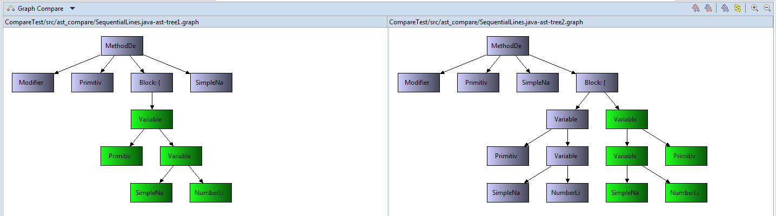
Result: TC finds proper as usual, TD shows finds same difference(100%), BU does not make a sense.
Comment: Better to use AST compare to see the difference (visually shows the difference on the graph)

Test 2 (test1 and test2)

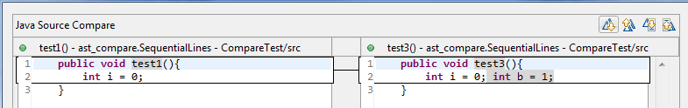
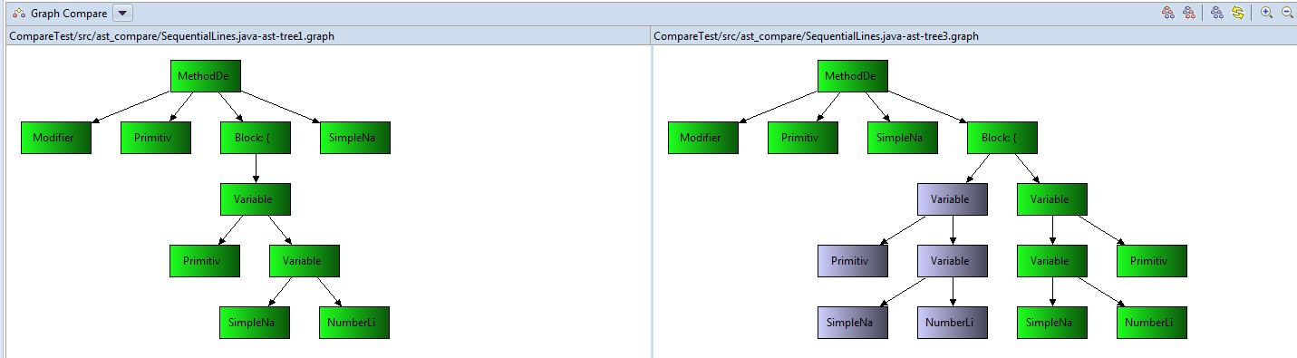
Result: AST generates tree independtly from how code lines organized. In this case two lines are in one but AST is built properly. Thus TD finds the difference undependent how the code organized.
Comment: Structure finds 100% difference via TD but name of variables is different.
Names variables have been changed

IF Blocks

Test 3(test1 and test2)
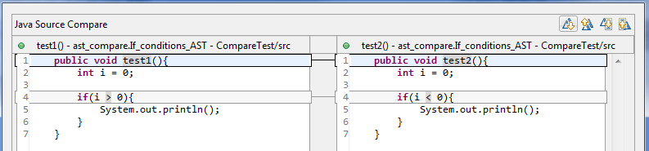
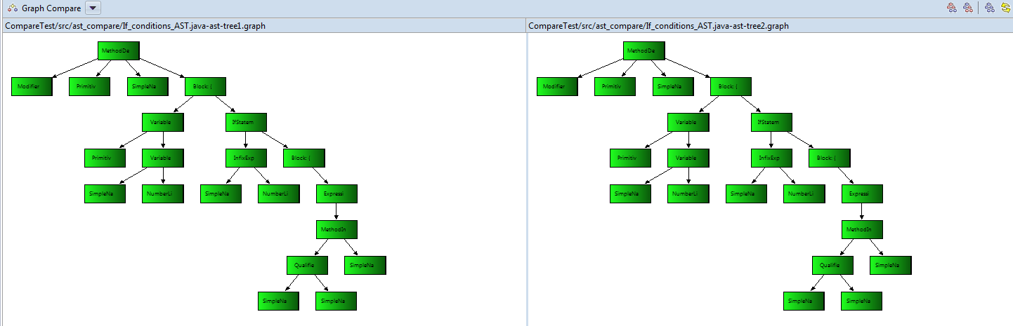
Result: if the business logic is totally different, the AST tree similarity is found completely.
Comment: Does not pass to define the logic difference how algorithms run.

Test 4(test1 and test2)
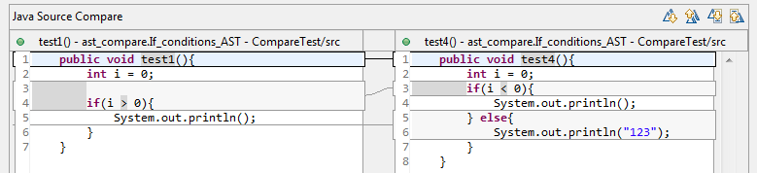
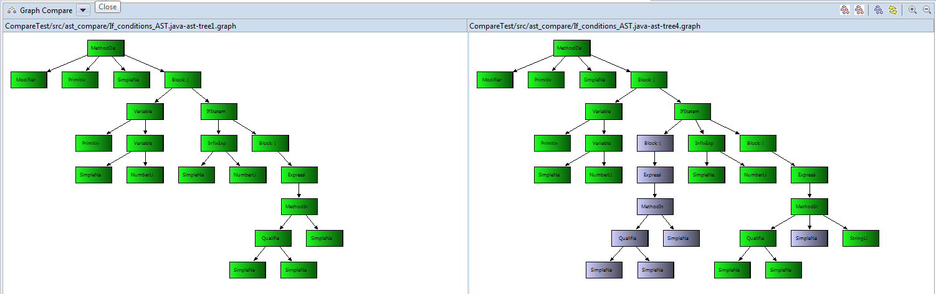
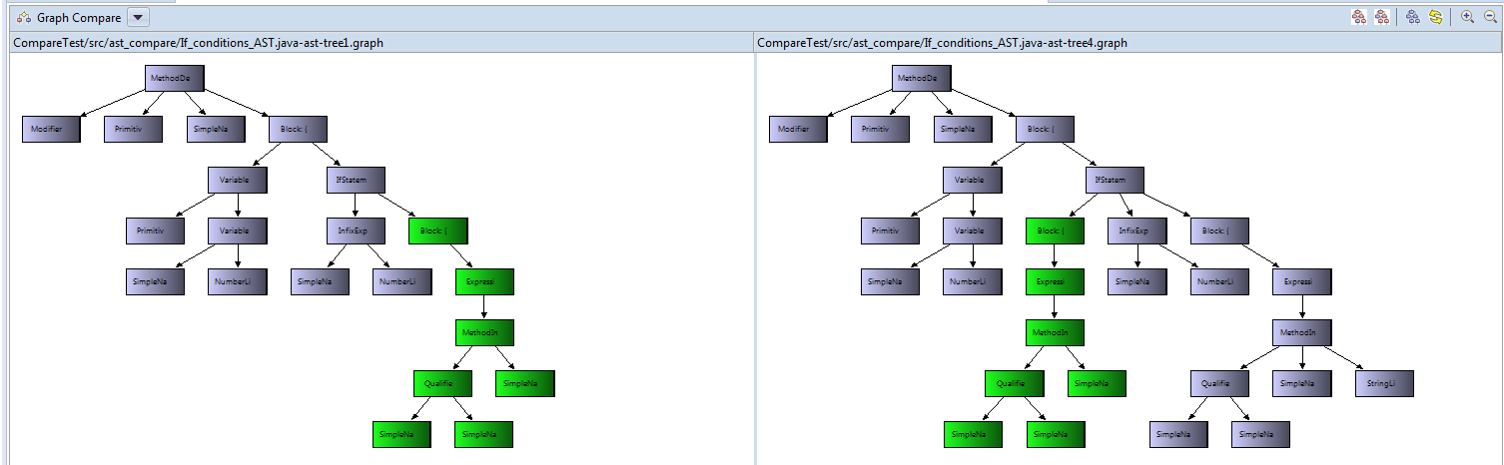
Result: visually you can identify the code difference
similarity:1- 8/27 = 70%
Comment: with good probability it can be said that these two pieces of code are 70% similar
TD can cover different nodes.

